LAB ASSIGNMENT-4



NAME: M Gyanada Chowdary

REG.NO: 21bce7727

COURSE: Computer Networks

SLOT: L21+22

Task:

CREATE AND CONFIGURE BUS, STAR, MESH, RING TOPOLOGOES AND CHECK THEIR WORKING.

**BUS TOPOLOGY:**

A bus topology is a type of**local area network** in which nodes (devices or workstations) are connected

to a single cable or single backbone.

Step 1:

Take 5 Switches and 5 Pc’s

Connect Pcs to switches with copper straight through cable.

And Switch to Switch with copper Cross over cable.

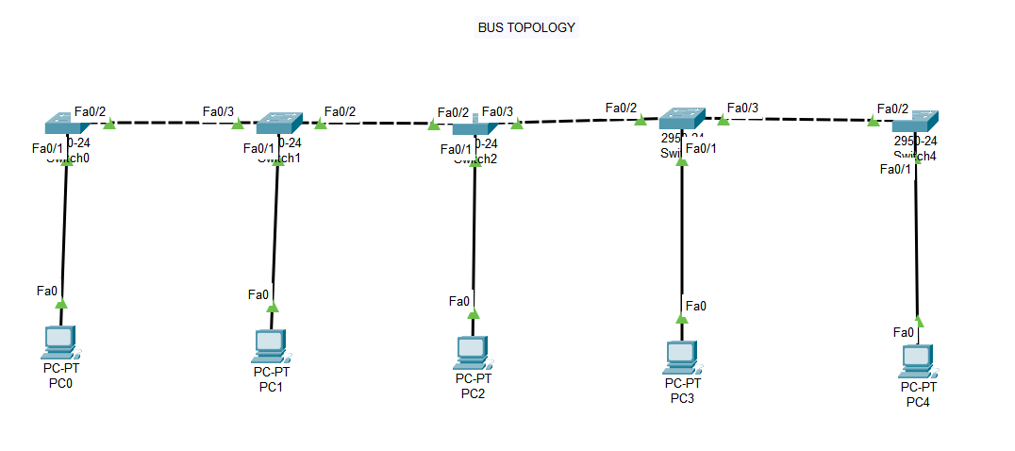

Step 2:

Assign IP addresses to the PCs and turn on the port status for switches.

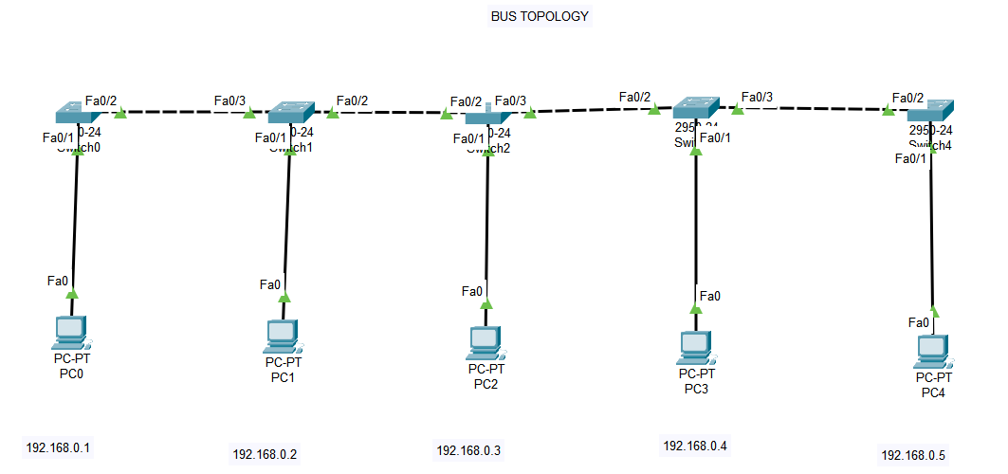

Step 3:

Take a simple PDU and check If the Topology is working.

Source – PC 0

Destination – PC 1

Steps:

1)

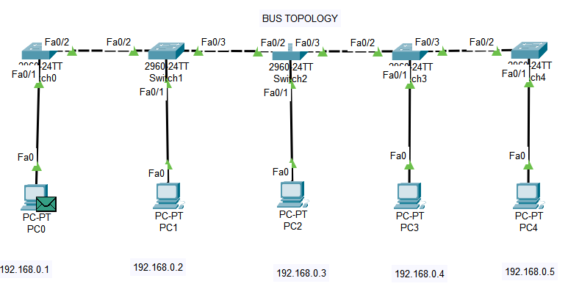

2)

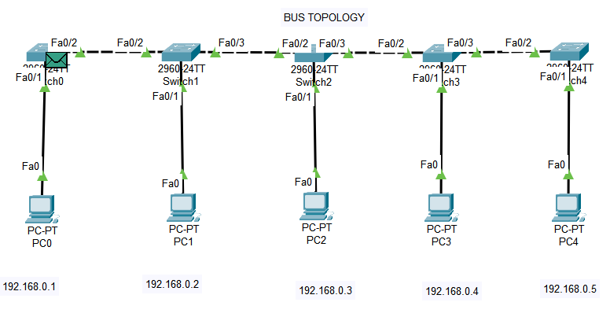

3)

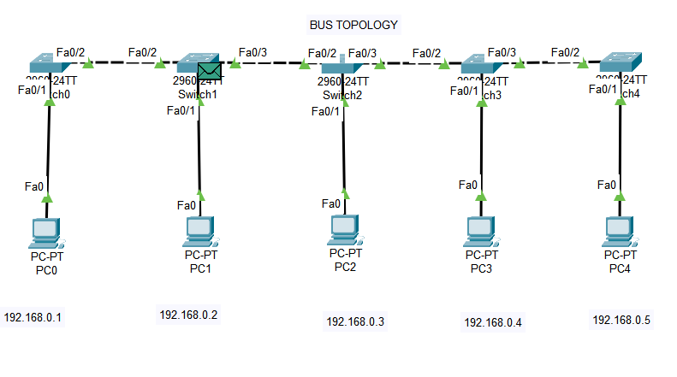

4)

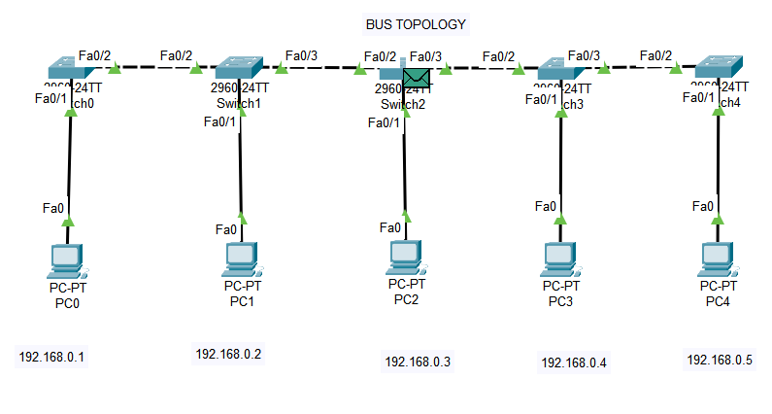

5)

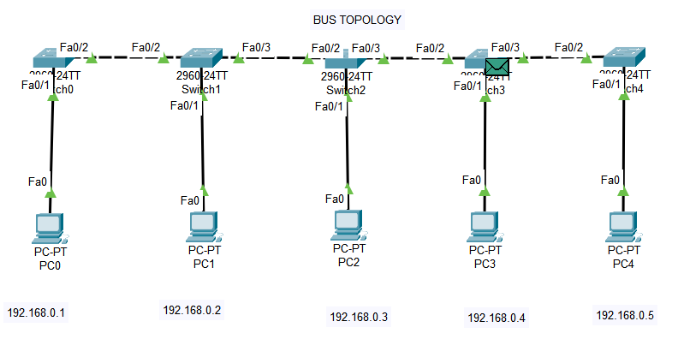

6)

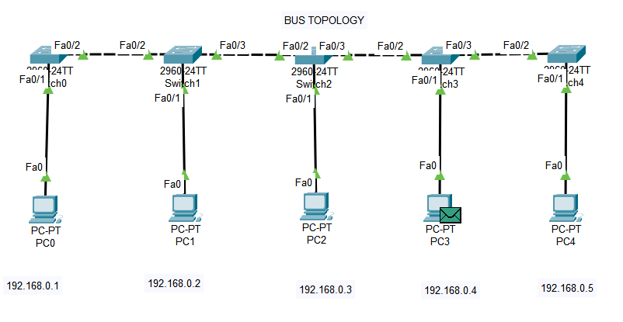

7)

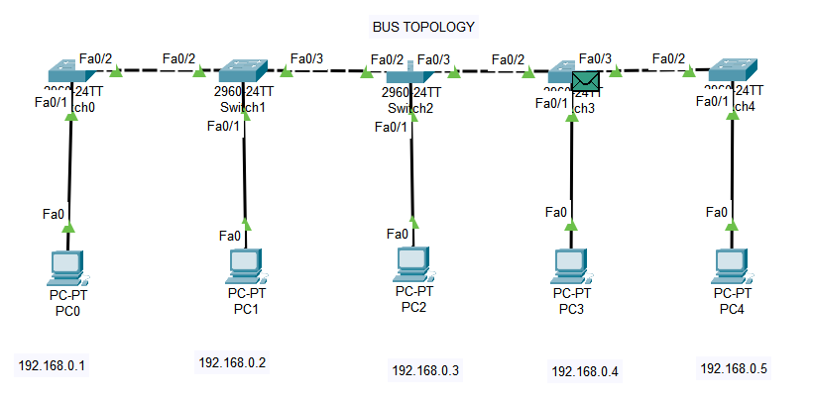

8)

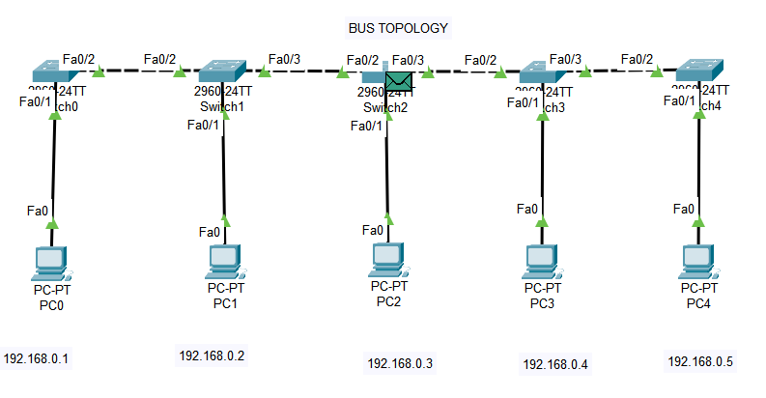

9)

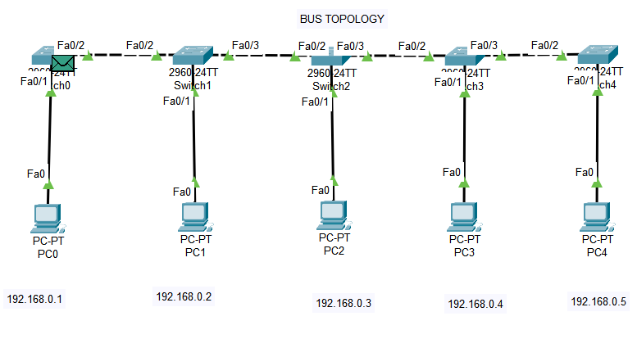

10)

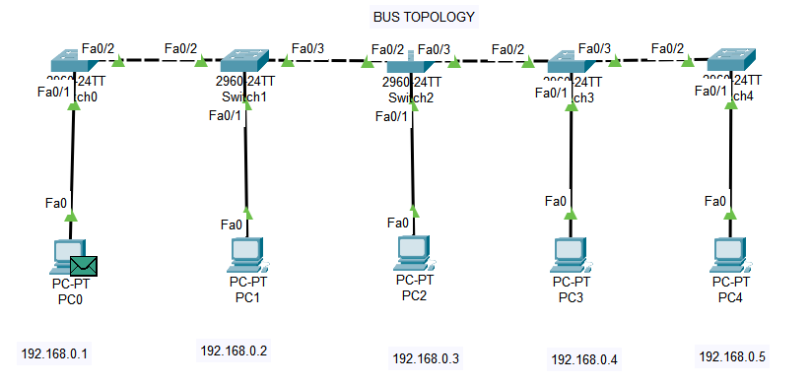

Final :

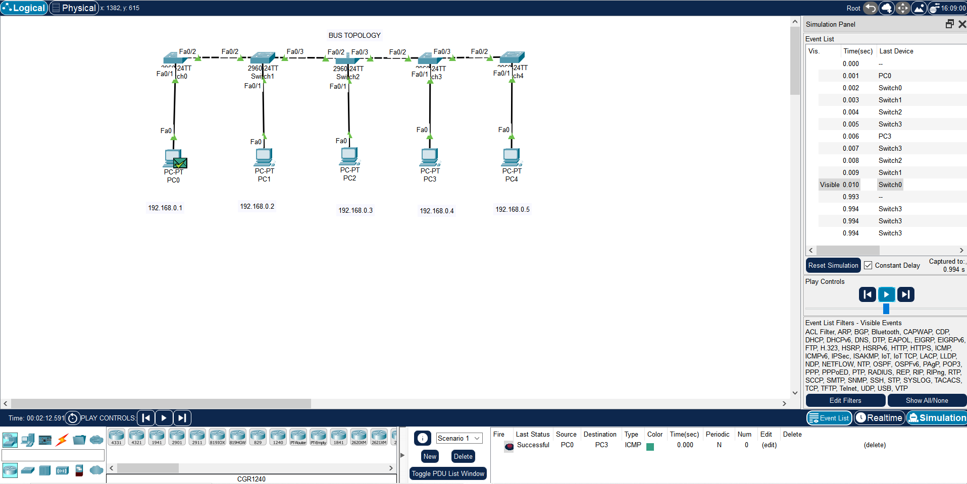

**MESH TOPOLOGY:**

A mesh topology is a network setup where each computer and network device is interconnected with one another.

Step 1:

Take 4 Switches and 4 Pc’s

Connect Pcs to switches with copper straight through cable.

And Switch to Switch with copper Cross over cable.

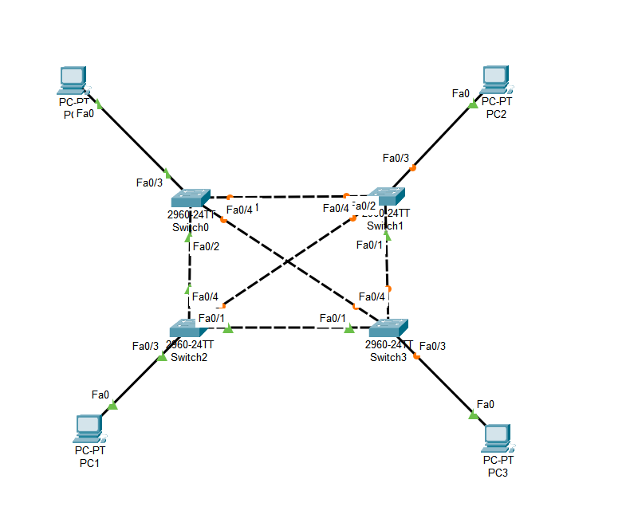

Step 2:

Assign IP addresses to the PCs and turn on the port status for switches.

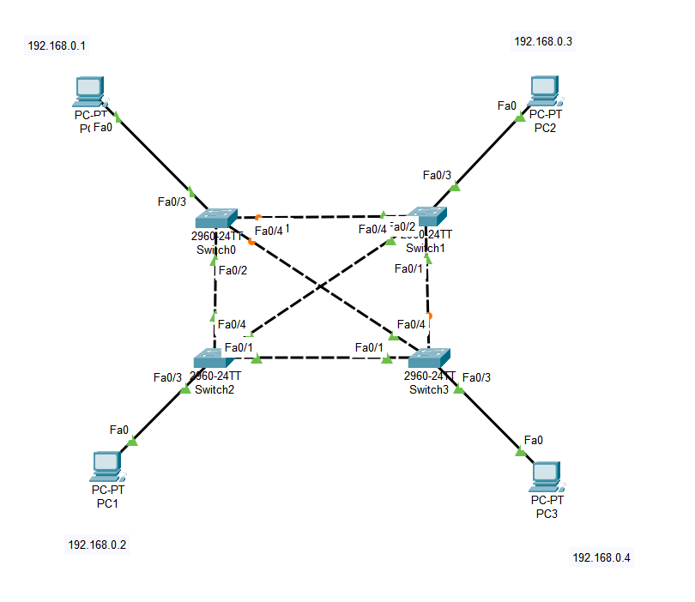

Step 3:

Take a Simple PDU and check if the topology is working.

Source PC0

Destination PC 3

Steps:

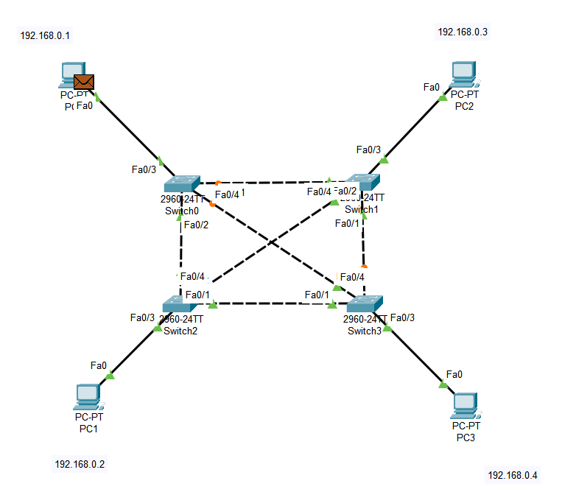

2)

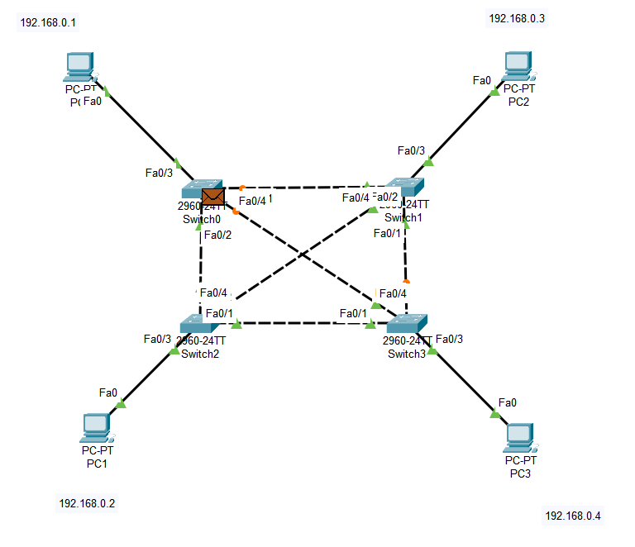

3)

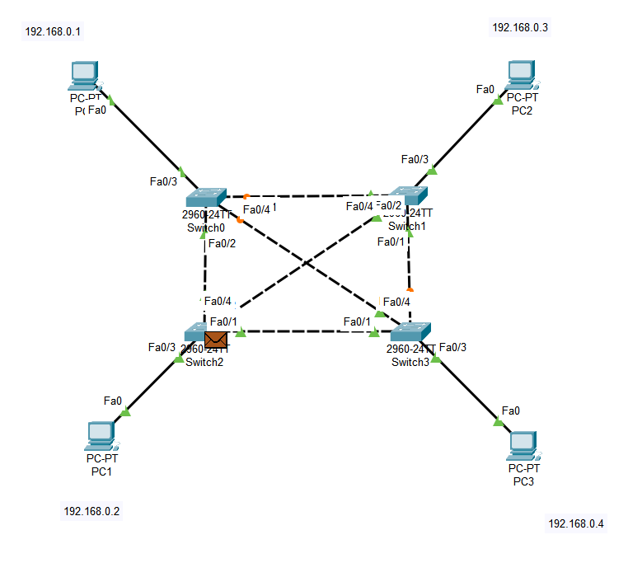

4)

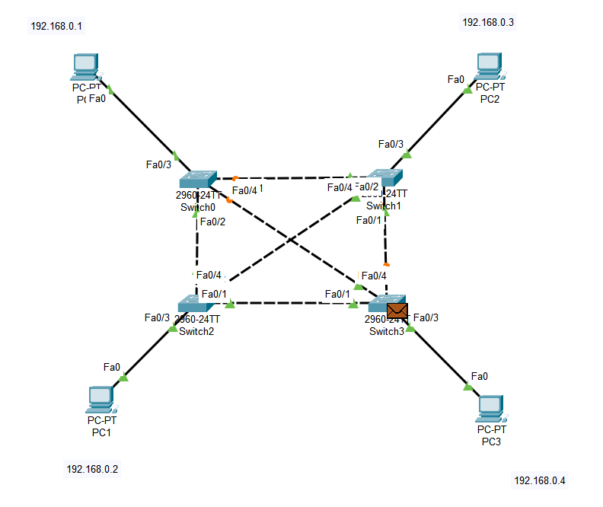

5)

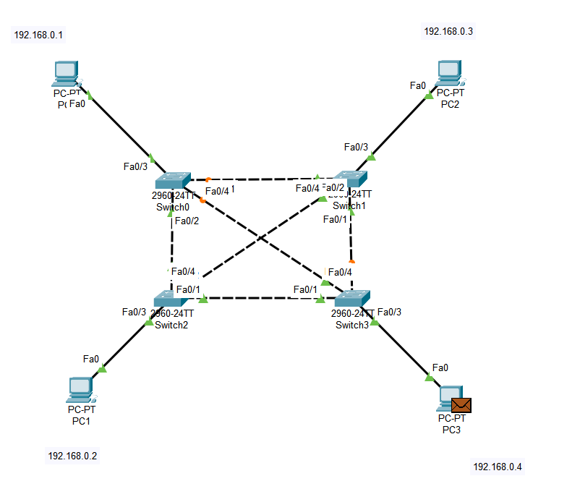

6)

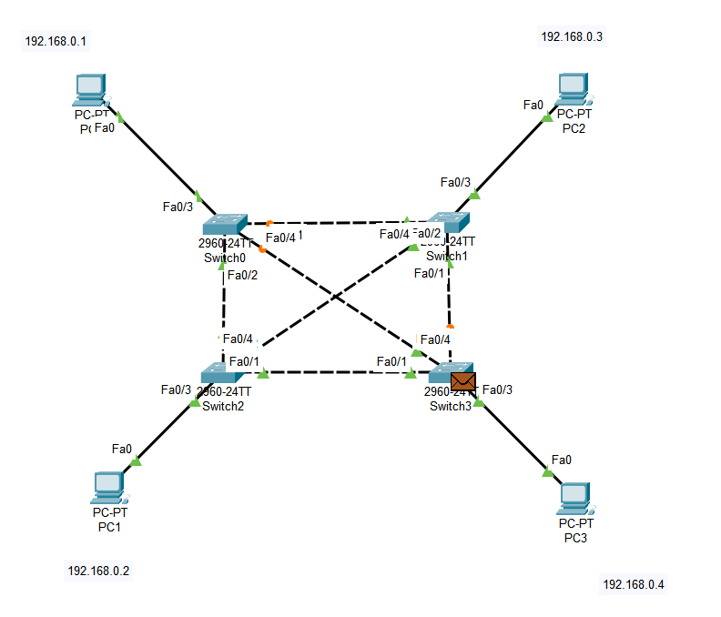

7)

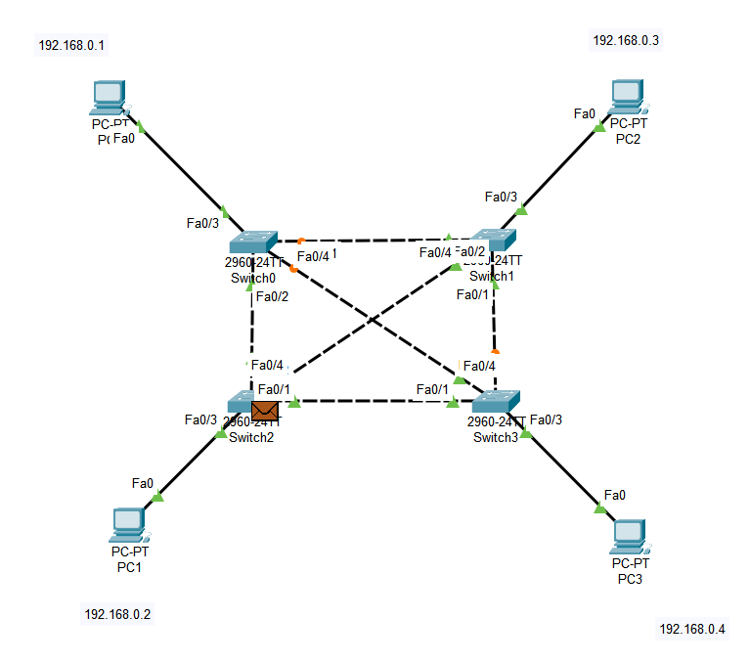

8)

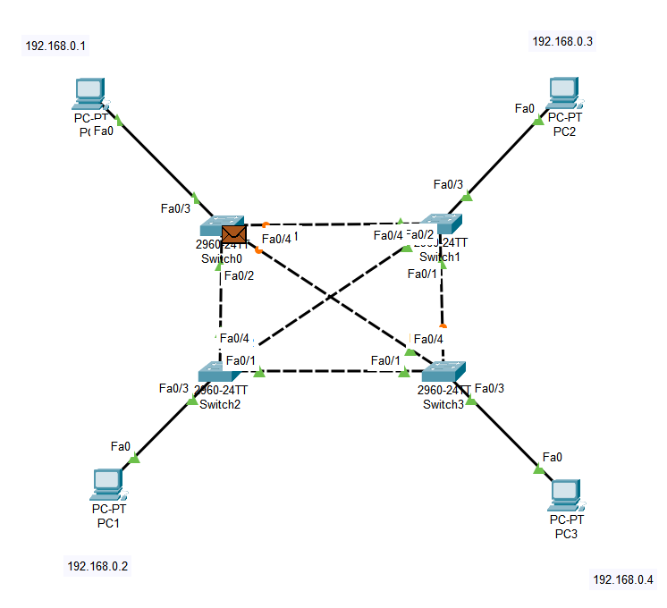

9)

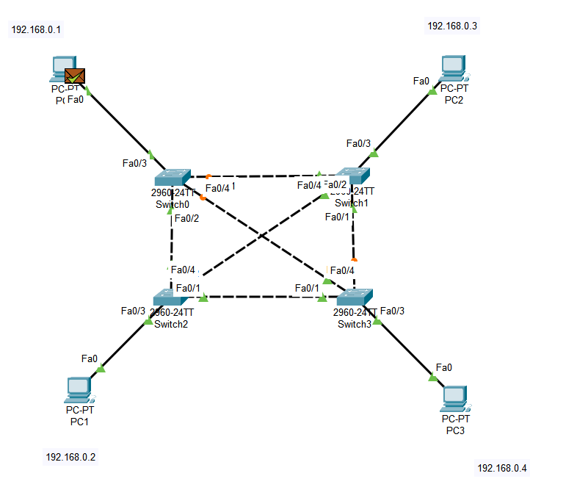

Final OUTPUT:

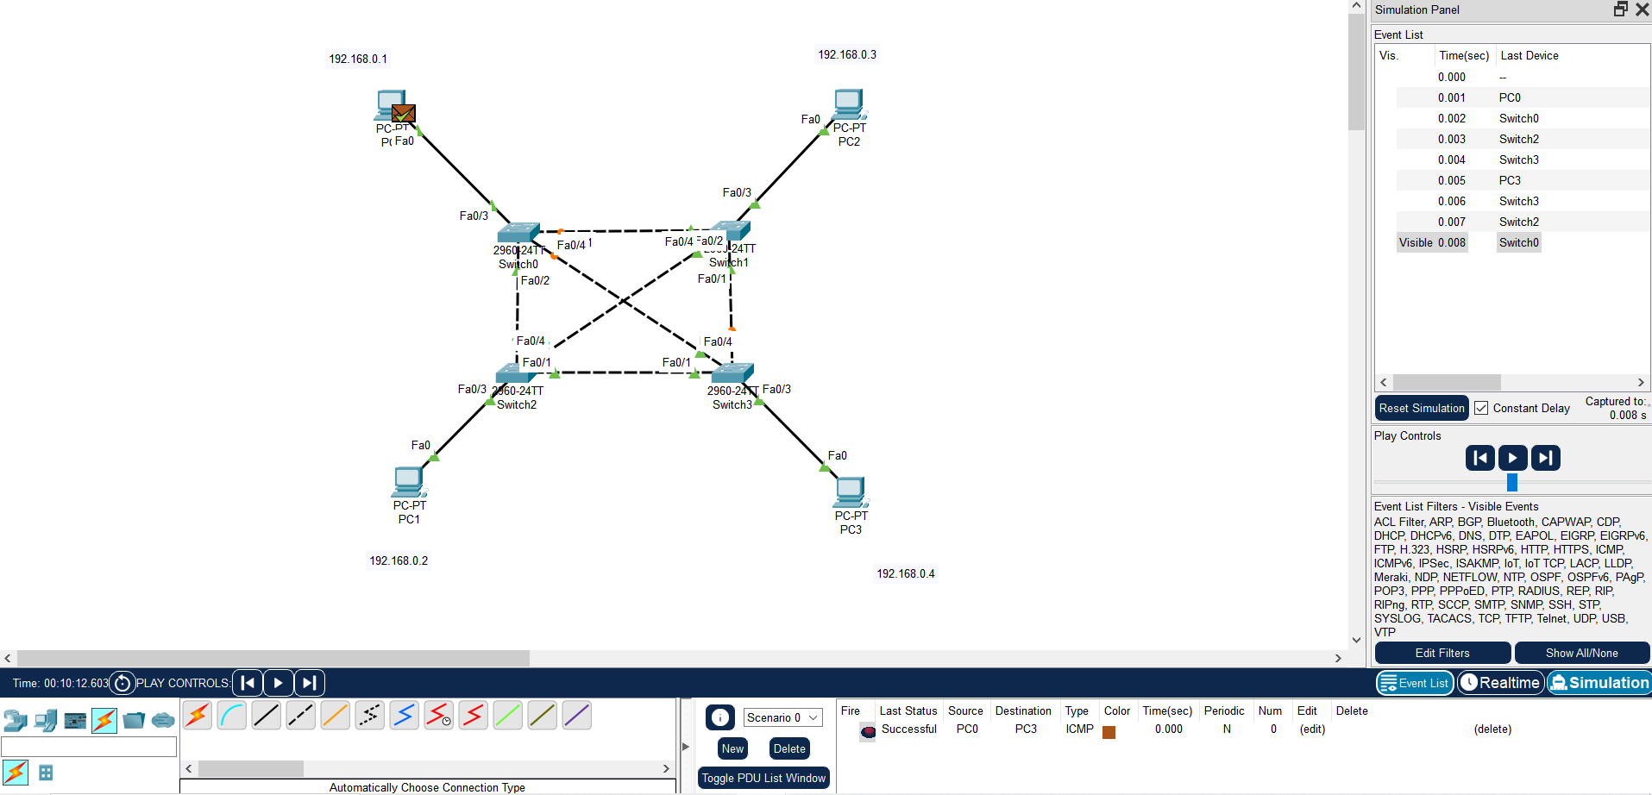

**STAR TOPOLOGY:**

Here all the nodes are individually connected to switch or hub.

Step 1:

Take 5 Pc’s and a switch

Take 5 PC’s and a hub

Connect Pcs to switches with copper straight through cable.

Connect PCs to hub with copper straight through cable.

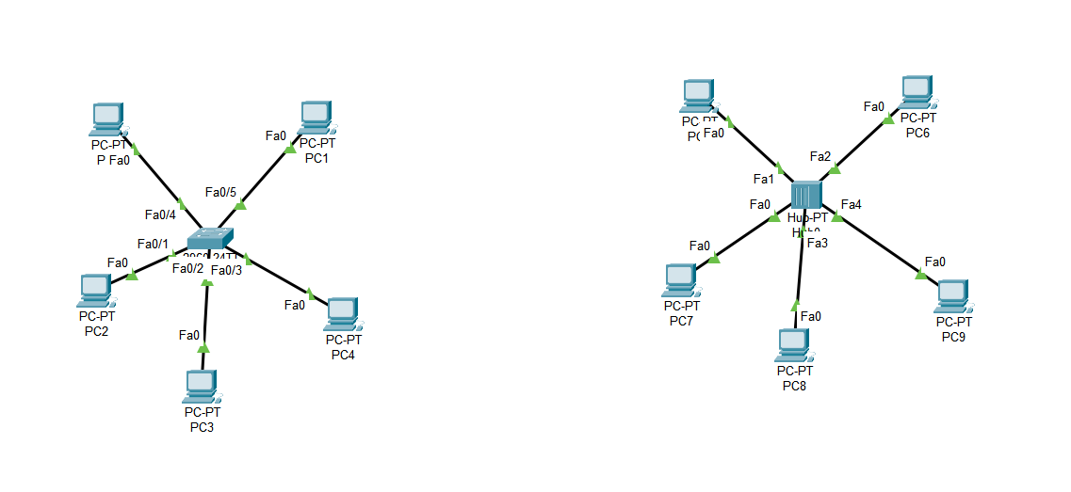

Step 2:

Assign IP addresses to PCs.

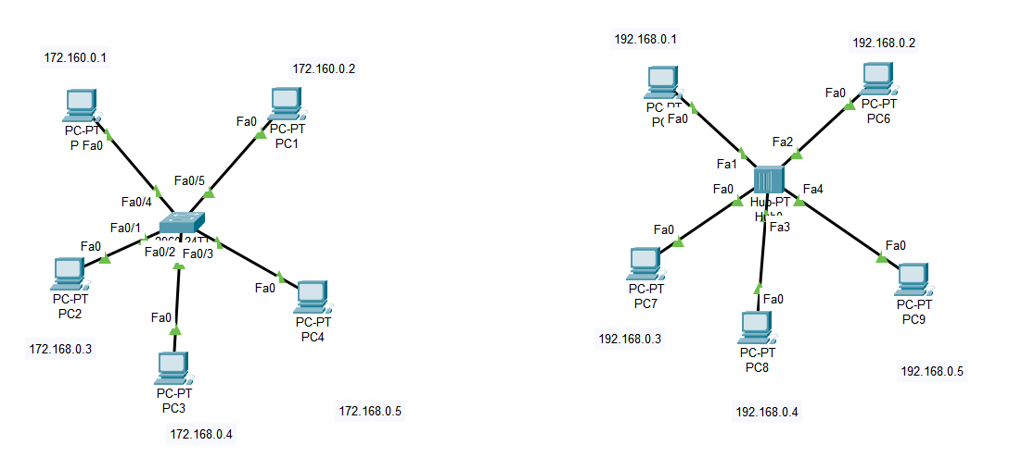

Step 3:

Take a Simple PDU and check if the topology is working.

Source PC0

Destination PC4(Switch)

Steps:

1)

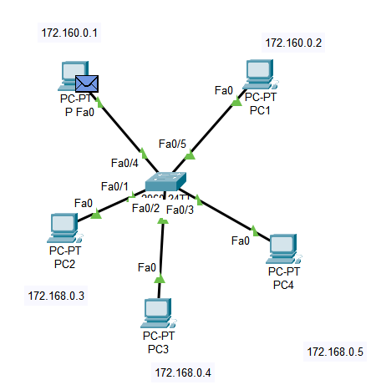

2)

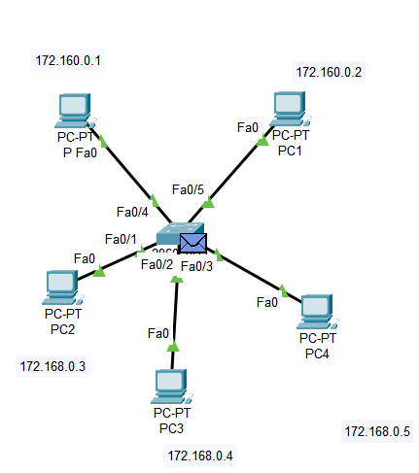

3)

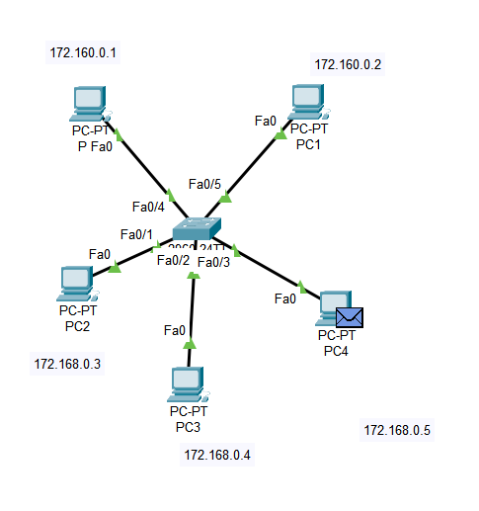

4)

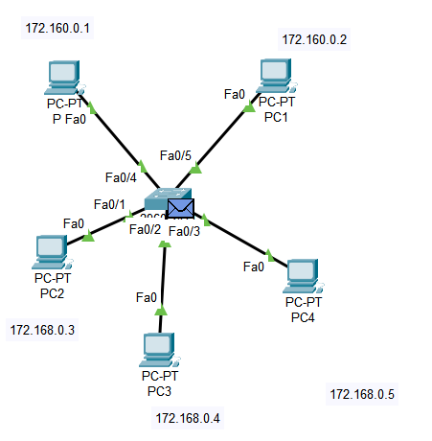

5) FINAL:

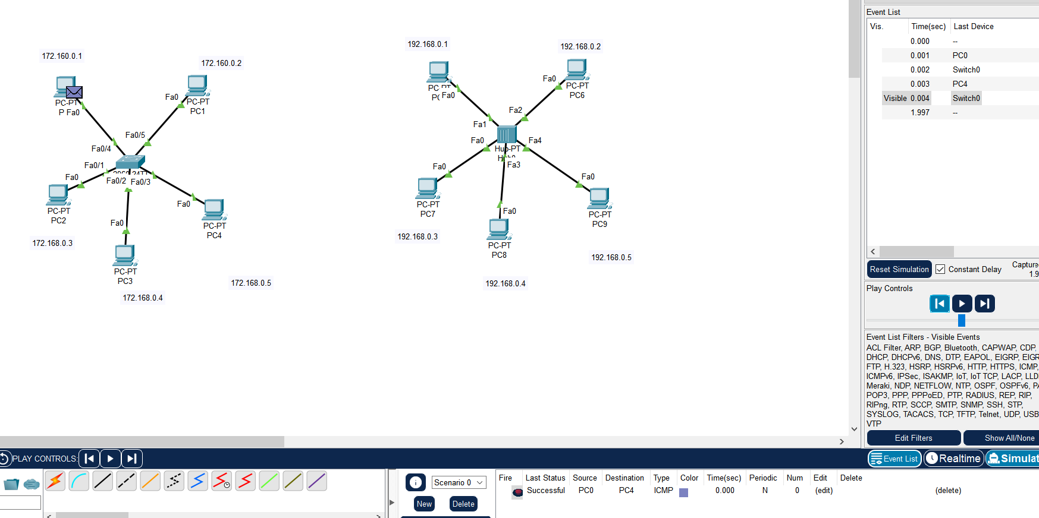

HUB:

Source PC5

Destination PC9

Steps:

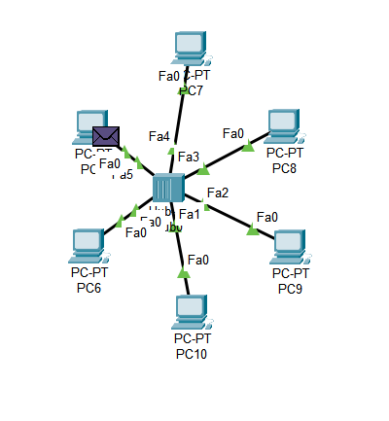

2)

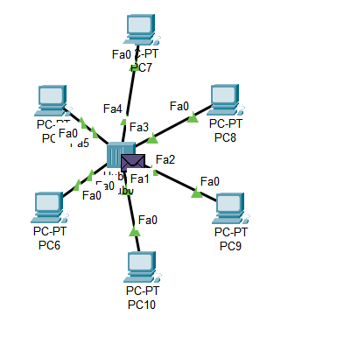

3)

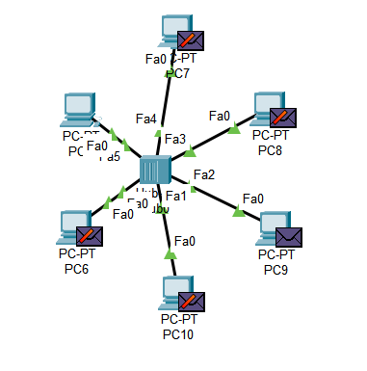

4)

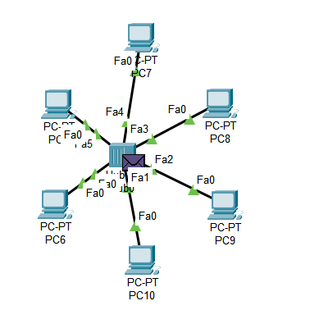

FINAL:

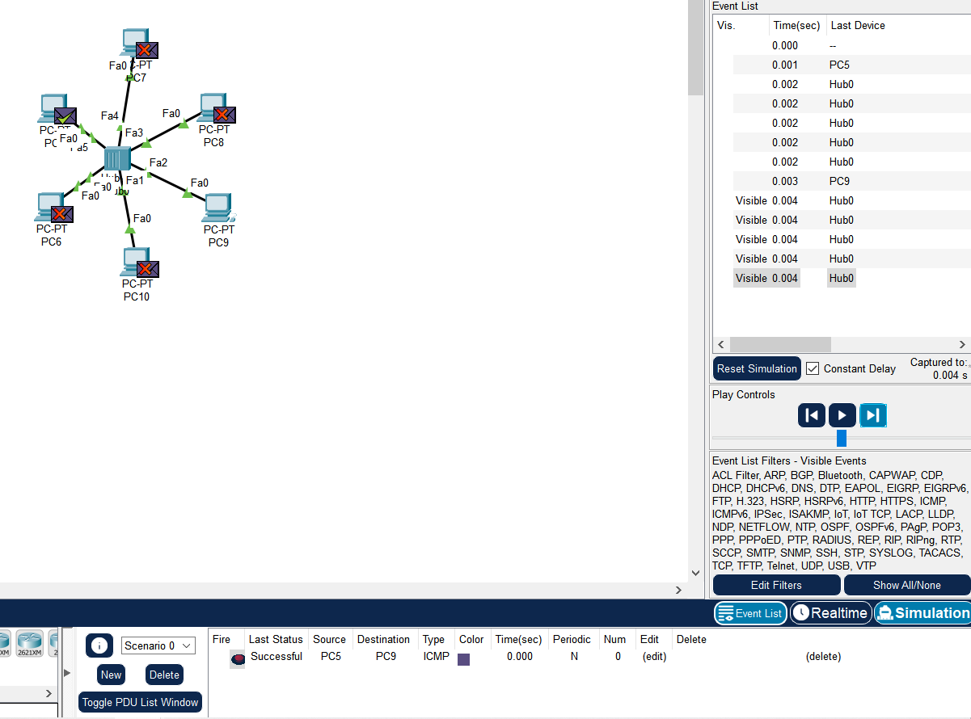

----------------------------------------------------------------------------------------------------------------------------------------------------------------------------------------------------------

**RING TOPOLOGY:**

All terminals are linked to each other in a closed loop connecting two devices on either side.

Step 1:

Take 4 Switches and 4 Pc’s

Connect Pcs to switches with copper straight through cable.

And Switch to Switch with copper Cross over cable.

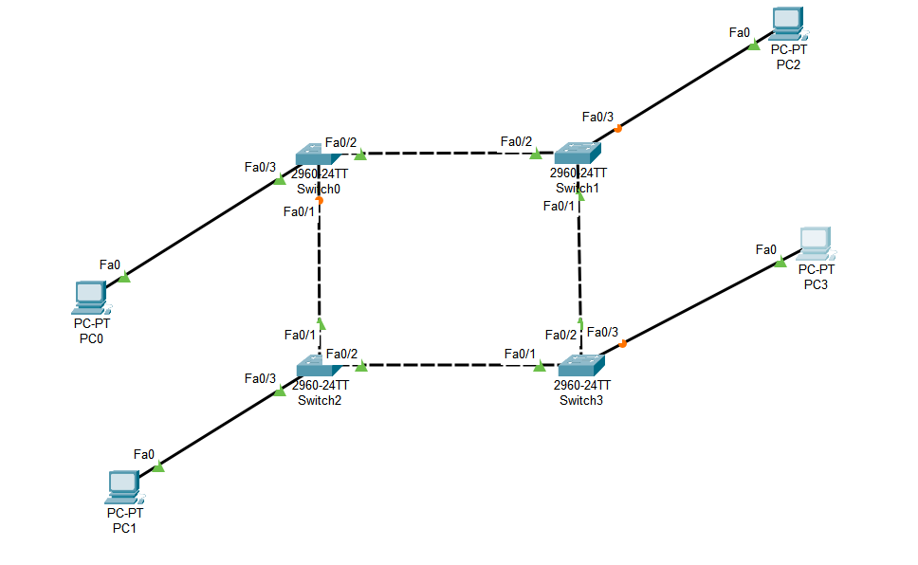

STEP 2:

Assign IP address to the PCs

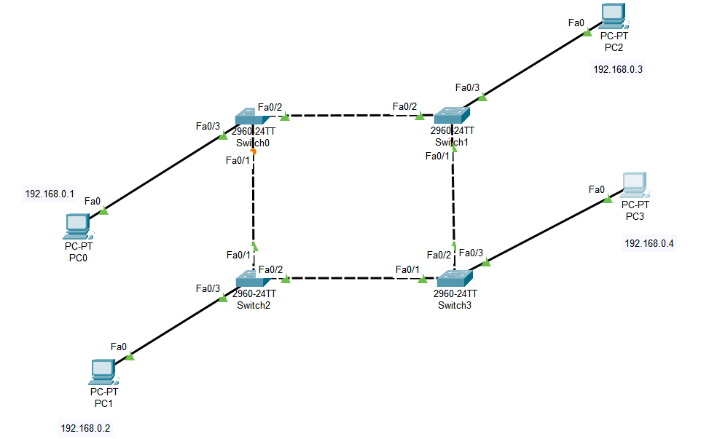

Step 3:

Take a simple PDU and Check it’s working

Source Pc0

Destination PC3

Steps:

1)

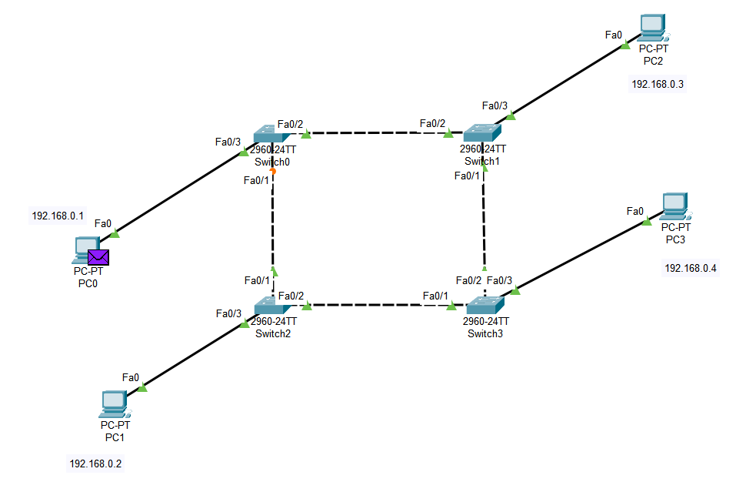

2)

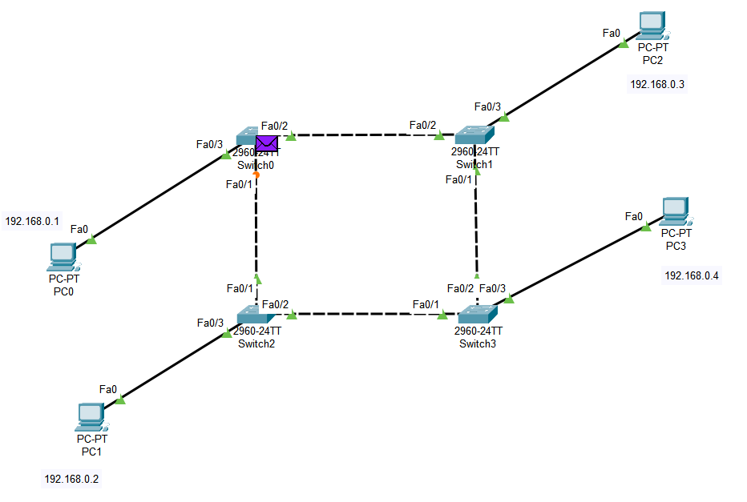

3)

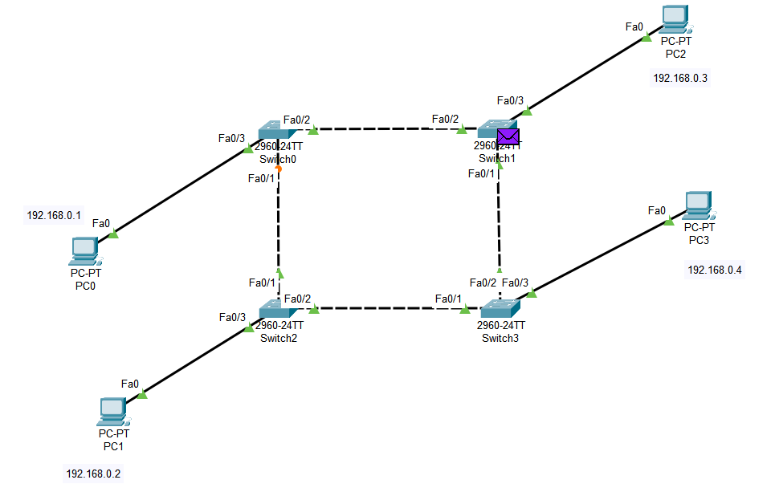

4)

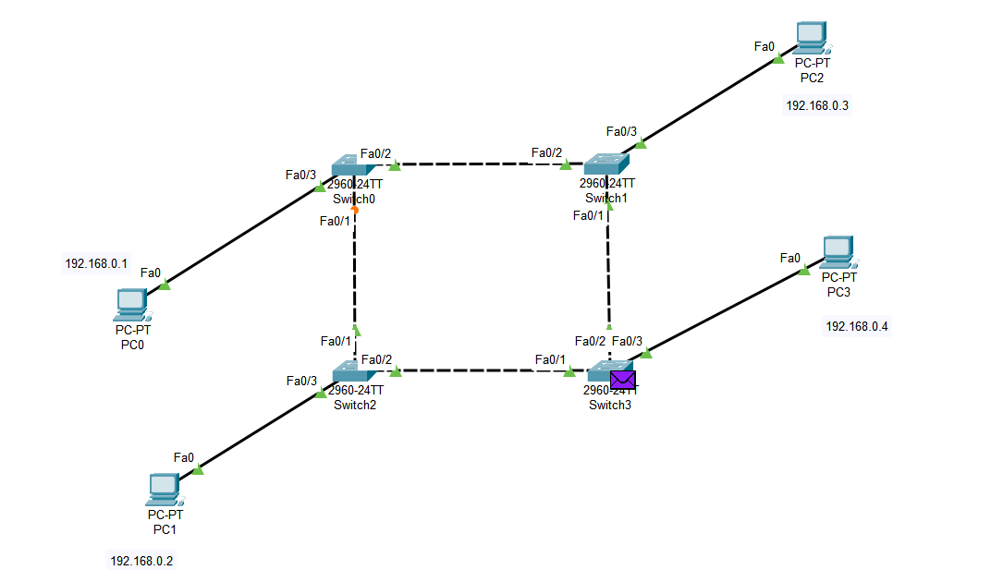

5)

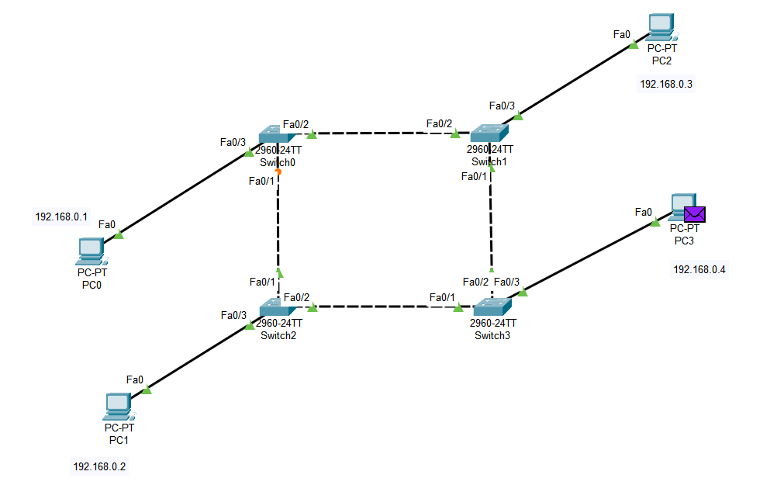

6)

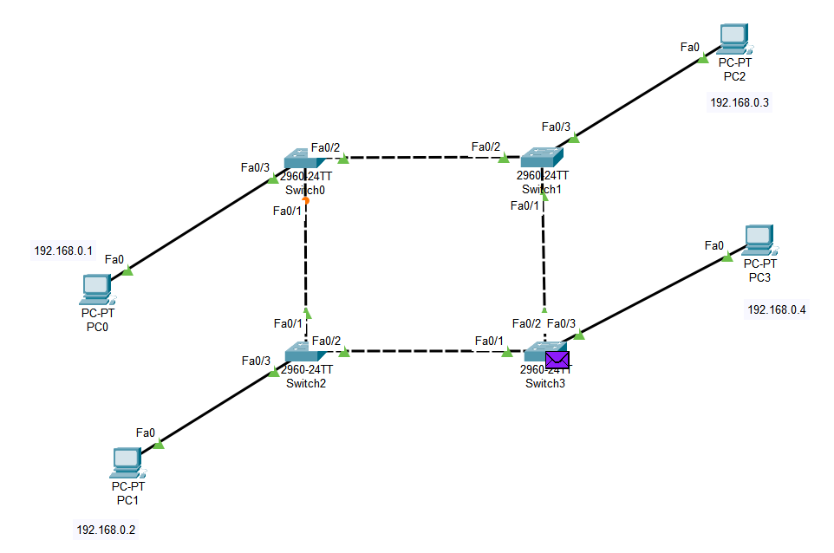

7)

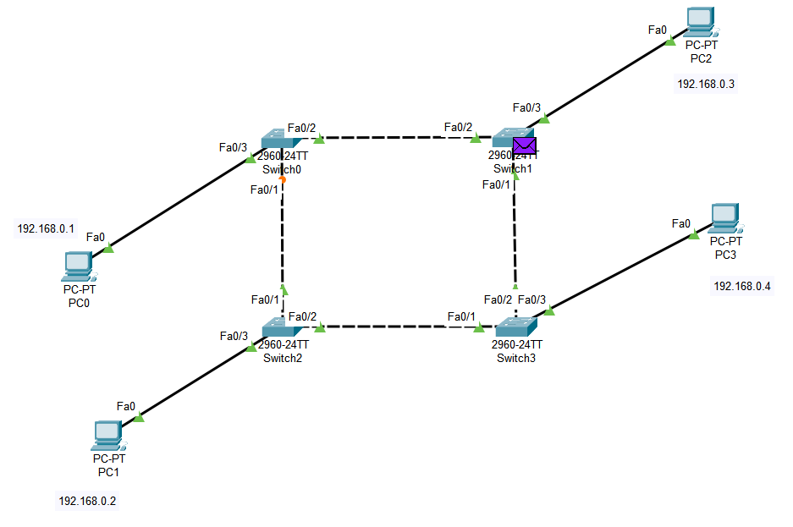

8)

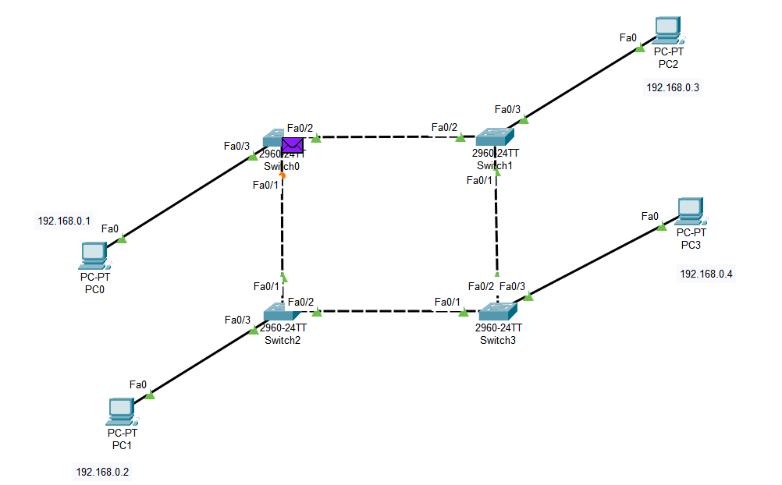

FINAL:

